Martyrdom of the Báb

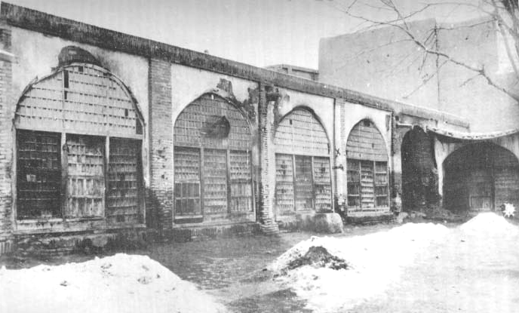
x
This account of the Martyrdom of the Bab represents the many accounts of the event rolled into a single short story without additions, and has been written in easy English. Notes are kept to a minimum, but on finding a passage of special interest, readers are encouraged to turn to the analysis and the original sources linked at the end. Those who only know the Dawnbreakers account are particularly encouraged to view those end links.
The Martyrdom of the Bab is commemorated in the UK at noon (13:00 BST) on 9 or 10 July.

Overview
This is the story of the final days of the Báb, who appeared in Persia in 1844 to challenge and reform the corruption of the land, and introduce to the world the appearance of Bahá'u'lláh and a new world Faith. Imprisoned in the Castle of Chihriq, he was conveyed to Tabriz for arraignment, back to the castle prison and again to Tabriz, meeting His death there in 1850. Suspended in mid-air with a disciple, He was executed by a detachment of soldiers in full view of thousands of people.
The story begins with the vision of Anis, promising him a death alongside the Báb...

Anis' Vision
Two years before His martyrdom and whilst imprisoned in the Castle of Chihriq, the Báb's message was spreading in that foremost of cities, Tabriz. There, a youth named Anis had the greatest fortune to hear it, and from that moment on he was overtaken with a longing to sacrifice himself for the message of the Báb. His stepfather, a notable of the city, deplored his state and the trouble it brought his honour, and forcefully confined the young Anis to his house. He placed a watch over him so that Anis could not leave the city to meet the Báb, and he languished in this confinement, tears continually raining from his eyes.
In due course the Báb was brought to this very city where, before the 15-year-old Crown Prince and his panel, instead of recanting, the Báb announced His station publicly and was beaten and returned to the Castle of Chihriq.
One day as Anis languished in despair in his confinement, he was in deep communion with the Báb, and the Báb appeared before him, in a vision of indescribable beauty, power and majesty. From that day on, this vision forever in his heart, Anis' became constantly filled with serenity and joy. In the vision, the Báb had told him how He would Himself be suspended before the eyes of the multitude in that same city and fall to the fire of the enemy, and that none but Anis would be chosen to share His martyrdom. "Rest assured," were the Báb's closing words, "that this promise which I give you shall be fulfilled."
One of his stepfather's relatives who was a follower of the Báb was able to persuade Anis to be patient and keep everything close within his heart, and in doing this he arranged for Anis' freedom.

In Chihriq
The Báb continued to be in prison within the Castle, at work and prayer, unalterably gentle. The King of Persia passed away, and was succeeded by the Crown Prince, who being so young relied entirely upon his new Prime Minister, who was most hostile to the Báb.
The Báb, seeing His fate approach, gathered together all His letters, documents, seals and other private possessions into a chest, and entrusted them with the key and a letter to one of the Letters of the Living for taking to one of His secretaries, urging the utmost confidentiality and care. That Living Letter after much journeying caught up with the secretary in his rented house. When he opened the chest they found among its items a spotless scroll of blue paper, of the most delicate texture that caused everyone to marvel, for on it the Báb had written, in the shape of a man-shaped star, hundreds of derivatives of the word "Bahá", so finely written that they appeared like a single wash of ink as no calligraphist might ever hope to rival. Everything was carefully returned to the chest, and following the Báb's instruction, His secretary pressed on to the capital Tihran and delivered them to Bahá'u'lláh.
The land was in turmoil from the unjust treatment and persecution of the imprisoned Bab and His followers, and the Prime Minister, rather than see justice pursued, further deepened the darkness by scheming relentlessly how to destroy the Bab, planning to lead the Báb publicly across the land to the capital, humiliating Him everywhere, and making Him look a fool; but fearing the Bab would transform it all into a triumph, he decided instead to move Him away to Tabriz with a view towards His execution, although knowing the Bab had been in prison He was entirely innocent of any crime.

Tabriz - In the Prince's Hands
So the Prime Minister, with scarcely anyone daring to protest, requested the Prince governing Tabriz to transfer the Báb to his city, which was the second capital of the realm, a journey of 180 km. The Prince was kind-hearted, and brought the Bab over with respectful escort and arranged the His accommodation with one of his friends, expecting He was going to be asked to release Him home.
In three days, however, the Prime Minister's own brother arrived revealing further requests for the Governor to have the Bab assessed before the clergy. The Prince tried to arrange this meeting, but the clergy shrank from meeting the Bab, instead demanding His death, and the Prince was instead forced to arrange that same evening a meeting his own to examine the Bab, composed of city notables in a poor position to examine the religious niceties at hand. Only the Bab's secretary was allowed to accompany Him, and the Bab was brought to the meeting in a disrespectful fashion, but the Prince went out of his way to seat Him in a position of honour. Questions and tests of a religious nature and inquiry about the upheavals in the land were made, but the meeting became heated with so many members opposed to the Bab and wishing Him to die. The Prince at its conclusion sent the Bab away home to His lodging and seeing how it was clearly going to end refused to have any more involvement with the matter, and handed the Bab's situation to the Prime Minister's brother. The official decree for the Bab's execution, the Prince told him, was a vile act which he would not perform.

In the Prime Minister's Brother's Hands
The Prime Minister's brother was about to arrange the Bab's immediate murder but instead, thinking a public execution would be much better and in view of the clergy's official condemnation still remaining to be obtained and a want of his own authority, reported back to the Prime Minister, a long distance which would take a week for the reply.
During this time, the Bab sent out Anis and several others with letters to the clergy of the city. One of these, treating the letter with contempt, led to a great disturbance as they defended the Bab, and the Prince had to put Anis and his companions in prison for a while to preserve the peace.
The reply from the Prime Minister came through, entrusting his brother with obtaining the formal condemnation and a public execution. The brother tried to communicate this to the Prince, but the Prince would not meet him and released Anis and his companions from their cell.
The Bab was led out by the brother to transfer Him to the barracks nearby, when Anis, still haggard and dishevelled from his recent release from prison, rushed into the crowd gathering around and forced his way through, breathless with excitement. Disregarding all personal peril, he flung himself at the feet of the Báb and seized the hem of His garment, passionately imploring Him to let him always be at His side. Two other companions, one also from the cell, unable to contain themselves, rushed forward, declaring their loyalty to the Báb. They were all seized and confined with the Báb in the barracks, and a large number of soldiers were placed on their guard.

In the Barracks
During their stay in the barracks, which lasted up to several days, Anis' brother continued to try to draw Anis away from the Bab so that he might return home and receive back his wife and family. Anis wrote back that he was content to die, and entrusts his family to God.
On the final night before the execution, far from being downcast, the face of the Báb was aglow with joy. Unmoved by the storm raging all around Him and conscious of approaching victory, He conversed with His companions in utmost gaiety and cheerfulness.
'Tomorrow,' said the Báb to His companions, 'will be the day of My martyrdom. Would that one of you might now arise, and with his own hands end My life; I prefer to be slain by the hand of a friend, than by that of the enemy.'
Tears rained from everyone's eyes; they each made their excuses, and remained silent, for no one wished to do such a thing. But Anis sprang to his feet and announced that the Bab had requested it, and he would obey Him. The companions prevented him from achieving this. The Báb however smiled approvingly and praised Anis' devotion. He requested everyone should disown Him, so that they would be released to convey to His followers everything they knew. Anis, unable to be separated, fell at the Báb's feet and entreated the Bab to be allowed to lay down his life with Him. After much persistence, the Bab permitted Anis' request. "This same youth," the Báb consented, "will suffer with Me in martyrdom: Him will I choose to share with Me its crown. Truly, Anis will be with Us in Paradise."

The Final Morning
At sunrise on the fateful morning, the brother ordered the chief hand to conduct the Báb into the presence of the city's religious leaders and gain their condemnation. As the chief hand carried this through, he interrupted the Báb during a confidential conversation with His secretary; the Báb turned, and warned him severely: "Not until I have told him all that I wish to say, can any earthly power silence Me. I shall not be deterred from fulfilling, to the last word, My intention."
The Báb, His secretary and Anis were taken to several of the houses of the leading clergy, who attempted to induce them individually to deny their Faith or face death, and quickly issued their written demands for the Bab's death. Following this, they were taken to the government house for the final civil authorisation for the plans to proceed, and from there through the city in a parade to the barracks Square for execution.
Insults, blows and brutalities bursting out with extreme violence and rained down on them for hours. The Bab walked unalterably firm, and Anis brazenly stood steadfast beside Him through this agonising and tiring ordeal, whilst the others, exhausted by long endurance, followed their instructions and renounced the Báb so that the His message could continue and were returned to the barracks. Seeing their success, Anis' young wife and little children brought before him, hoping the rain of their tears and entreaties might conquer his resolution; but Anis remained steadfast, declaring his faith in the most forthright manner.
The Bab and Anis in iron chains, collars clamped around their necks and barefoot, the Bab without cloak or turban, were dragged to execution by a cord with violence and taunts, stones and mud cast at them through all the teeming streets and bazaars of the city.
At length our exhausted heroes arrived at the barracks, and Anis was put back in the cell whilst the Bab was led to execution. Anis however was not content to be there, and at great insistence was brought outside to join the Bab.
The colonel was greatly moved by the godly behaviour of the Báb, and was seized with fear that he might be performing an act that would condemn him before God. "Enable me to free myself from the obligation to shed your blood," he requested the Báb. The Báb however bade him continue with his instructions, and assured him that if he were sincere the Almighty would be able to deliver him from his perplexity.
Exhausted and weary of finding their efforts fruitless, the Báb was brought out through the first door that led to the square, and reaching the roof of the cistern, He stopped for a moment before a number of nobles and prominent persons present there. All begged the Báb to renounce His claims and not spill His blood in such a famous city. The Báb paid no attention, and remained wholly calm, showing no signs of fear, anxiety, or confusion. The chief hand came to the commander and showed him the order for the execution of the Báb and His companion, but the officer refused to obey an order from outside his ministry, and so he went out to the colonel, who appointed a detachment of the regiment to carry out the order.

Suspension 1
Opposite the cells on one side of the Square, also known as the 'Square of the Lord of the Age', one or more spikes were driven in under the eaves of the cells, from which Anis and then the Báb were suspended by separate heavy ropes. The Báb remained silent, the beautiful features of His pale handsome face framed by a black beard and small moustache, His appearance and refined manners, His white, delicate and well-shaped hands, His simple but very neat garments - everything about Him awakened sympathy and compassion. They were placed so that they were looking into the stone, but Anis begged to be turned to face the soldiers so that he could see the bullets flying toward him. The officer granted his request. Anis implored to be executed before the Bab. He asked that his face be placed right down upon the Báb's feet or positioned to shield the Báb from bullets so that the Bab would not be hit by the first bullets aimed at him, however the officer did not acquiesce and their shoulders were bound firmly so that Anis' head was against the Báb's breast, both suspended three metres from the ground. His relations and friends cried out that he was mad, and therefore unlawful to receive the death-penalty; but Anis responded, "I am in my right mind: perfect in service, and in sacrifice." Anis calmly spoke aloud excerpts from the prayers of his Master, whilst the Báb remained peaceful and silent throughout.
As soon as they were fastened, a certain detachment of soldiers from the regiment were ranged with their guns into three files to fire.
The surroundings and housetops billowed with a crowd of about ten thousand impatient spectators. One of the Báb's followers was said to be amongst the people with his sword on, foolishly waiting for an opportunity to attempt a rescue, but he found himself suddenly overcome with drowsiness, and was forced to sit down, weak and insensible.
The colonel gave the order, and the soldiers raised their guns as for salute. The people fell silent, as though everyone had stopped breathing. Hearts pounded, joints shook, one could hear the hum like the hum of flies' wings. At the second command such silence descended upon the people as if a bird were perched on their heads. One could hear the beat of hearts and pulses. At that moment the colonel glanced toward the chief of the governor's gate keepers who held in his hand the order for execution, and then received the signal to carry it out. The colonel signalled the head of the squadron and ordered the first file to fire.
As the firing-party made themselves ready, Anis, whose name was Muhammad 'Alí, was heard to say to the Báb, "Master, are You content with me?" The Báb replied to him in Arabic, "Verily, Muhammad 'Alí is with Us in Paradise!" As these words were spoken, the crash of musketry rang out as the soldiers discharged their guns in a vast hail of bullets at Anis.
The next file awaited the orders to fire, and a discharge of guns fired toward the Bab. A mighty smoke was produced, and for a moment the rolling cloud of smoke hid the bodies of the prisoners from the crowds of onlookers as they watched that sad and moving scene. The bullets cut the Báb free without touching Him, releasing Him to the ground without a scratch, and He walked back into the cell to finish His conversation with His secretary. As the smoke and dust thinned, the astounded multitude beheld a scene their eyes could scarcely believe. Although Anis could be clearly seen through the smoke, yet the Báb was nowhere to be seen. Perhaps, they wondered, Anis might also even be alive? Uproar arose on all sides, a great clamour of wonder, admiration and awe broke forth amongst the bewildered people, as they proclaimed the Bab had disappeared, perhaps flown through the air, or even ascended up into the skies.
The authorities saw with great fear the populace ready to veer around in favour of one who but an hour ago they had been jeering and pelting with stones. The colonel ordered the soldiers to form together a wedge, and they stopped the people's rush.
A frenzied search of the vicinity followed, and a soldier discovered the Báb seated in the same room where He had been lodged the night before, engaged in completing His interrupted conversation with His secretary. An expression of unruffled calm was upon His face, unscathed from the shower of bullets which the regiment had directed against Him. Some say that the soldier made a cut at the Báb with his sword, and the others, seeing the pool of red blood flowing from their unresisting victim, lost their fear and hastened to complete their work of death. "I have finished My conversation with My secretary," the Báb told the chief hand: "now you may proceed to fulfil your intention."
The chief hand, recalling His Prisoner's bold assertion previously made, was too much shaken to resume what he had already attempted. Refusing to accomplish his duty, he abandoned the scene in terror and resigned his post. The colonel of the regiment likewise, stunned by the force of this tremendous revelation and recalling the confident and reassuring words the Báb had made him just a short while before, ordered his men to leave the barracks immediately, and refused ever again to associate himself or his regiment with any act that would involve the least injury to the Báb, swearing he had performed his order, and would never resume the task though it should entail the loss of his own life.

Suspension 2
No sooner had they departed, than the Colonel of the Bodyguard stepped forth and volunteered to continue the order for execution. The Báb was dragged forcefully from the recess and shown before the crowd. An intense clamour arose at this moment as the onlookers saw the Báb free from His bonds and advancing towards them. The soldiers held up to the people's gaze the broken ropes as if to wonder what there was to marvel at. They again tied the Báb against Anis suspended to that fatal post, whilst a large-scale force of soldiers formed in lines ready to open their fire, determined not to see a repeat of their humiliation. It was now two hours after the execution had begun. This time, the Báb was not silent.
"O people, am I not after all the son of God's Apostle? Do not approve such injustice and cruelty towards me! Fear God, and have some shame before His Apostle! What is my crime, save that I have invited you to the knowledge of God, and called you to the Kingdom of Unity, and cast myself into affliction and suffering for your sake?"
"Had you believed in Me, O wayward generation," were the last words of the Báb to the gazing multitude as the soldiers prepared to fire their final volley, "every one of you would have followed the example of this youth, who stood in rank above most of you, and willingly would sacrifice himself in My path. The day will come when you will have recognized Me; that day I shall have ceased to be with you."
Suddenly the orders were given to fire, and that holy Spirit, yielding from its gentle frame, returned to the Supreme Horizon. Their breasts were riddled and limbs completely dissected by the bullets, their bodies shattered and blended into one mass of mingled flesh and bone; yet their faces remained untouched, a smile still lingering upon the Báb's face.
The crowd, deeply impressed by the spectacle they had so strangely witnessed, dispersed slowly, hardly convinced that the Báb was a criminal.

The Remains of the Bab and Anis
The mangled remains of the Bab and Anis were left suspended in public view until the evening, some record for several days as His followers lay in watch hoping to retrieve the remains, when by order of the Prime Minister's brother, they were lowered, ropes tied to their legs, removed from the courtyard of the barracks, and dragged through the streets and the bazaar to the gate of the main street. Reaching the edge of the city, they passed through the gate and threw the bodies into the city ditch opposite the middle tower, to feed the dogs and jackals, the body of the Báb left lying on its left side. Soldiers were ordered in turns of ten to keep watch over them to prevent anyone attempting to retrieve the precious remains.
The next morning, the Emperor of Russia requested his consul in the city to investigate fully all these circumstances. He went to that spot with an artist, and an accurate drawing was made of the remains, as they lay beside the moat.
On that same night with assistance from the mayor, one renowned for his exploits appeared before the soldiers with a few others, holding out an offer of a very large bribe in one hand or a sword in the other. The guards, greedy for gain and fearing for their lives, chose the large sum of money and surrendered the bodies. On bringing the remains out to a Silk Factory, they were enshrouded in fine silk, laid in a specially-made wooden casket and a flower placed next to the Bab's face, and at the order of Baha'u'llah conveyed secretly to the capital Tihran.
On the next day, the bodies were discovered missing, and the guards had to explain where they had gone; so they pretended the wild beasts had carried them away. Their superiors, fearing a rebuke if it were known the bodies had been stolen, endorsed and spread the story abroad, whilst the clergy jubilantly proclaimed it from their high pulpits, for a holy person, it was believed, would never be devoured by beasts of prey, whilst the followers of the Báb in their turn were very happy with these stories being spread, ensuring the remains would not be sought after.

Conclusion
After a great many years and a very long journey, being transported secretly from place to place, the remains of the Báb and Anis eventually reached the Holy Land, where they attained their eventual rest.

Parallels between Jesus and the Báb
Anyone reading the martyrdoms of both Jesus and the Báb, will notice some very intriguing similarities...
- The age of the Báb and length of His mission are similar to those of Jesus.
- Both had farcical trials with predictable conclusions.
- The Báb is put to death on the eve of Ramadan, exactly as Jesus is martyred on the eve of Sabbath and the Passover, for the same reasons.
- The Báb being in one account paraded through town on an ass recalls Jesus' entry into Jerusalem.
- The Báb met His martyrdom at noon, which is the time Jesus was taken away to His death in John.
- Both are suspended in the air (some accounts describe a cross-like arrangement), have one fellow-companion going to Paradise, and the same words are uttered for their going there.
- The Báb instructs His disciples to deny their faith, much as Jesus' disciples fled and denied Him in order for His faith to continue.
- Both the Báb and Jesus demonstrate a power over martyrdom that shows it was a voluntary death.
- Both are depicted being struck by a sword / spear.
- The disappearance of the Báb before the people, is similar to Jesus' disappearance from the tomb.
- A long darkness (and other natural wonders) follows the deaths of both the Báb and Jesus.
- Guards are posted over both the Báb's and Jesus' bodies so that their bodies are not taken, but both fail in their jobs.
- The bodies of both the Báb and Jesus are both found disappeared on the third day.
- In both cases an excuse is spread abroad to cover the disappearance.

Contents
Overview 1
Anis' Vision 2
In Chihriq 3
Tabriz - In the Prince's Hands 4
In the Prime Minister's Brother's Hands 4
In the Barracks 5
The Final Morning 6
Suspension 1 8
Suspension 2 11
The Remains of the Bab and Anis 12
Conclusion 13
Parallels between Jesus and the Báb 14
Contents 15
Info 15

Info
Author : David Merrick, Edinburgh
All comments appreciated : www.paintdrawer.co.uk/david/email.php
This Version : 2026-07-30 19:32
Latest Version : www.paintdrawer.co.uk/david/folders/Spirituality/005=Collections/holydays.htm
Sources : www.paintdrawer.co.uk/david/misc/18500709src.rtf

In-Depth Analysis : paintdrawer.co.uk/david/folders/Research/Bahai/Bab/bab-martyrdom-outline.htm

Photos and a map follow on the next page...

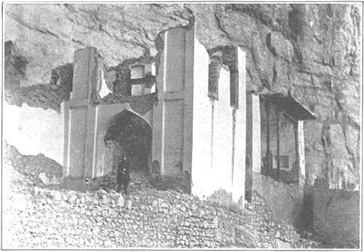
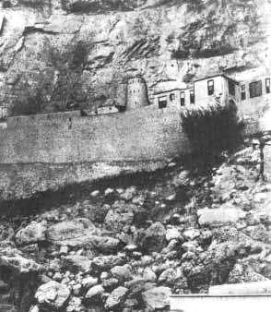
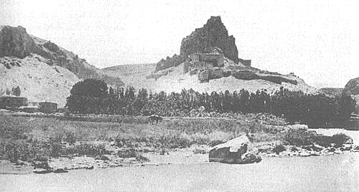
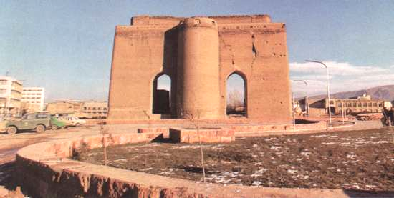
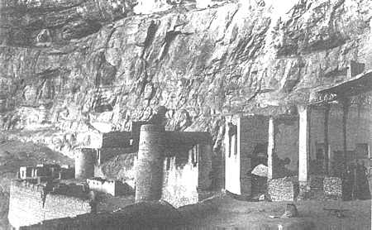
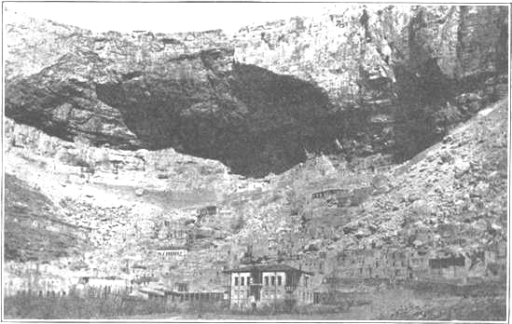
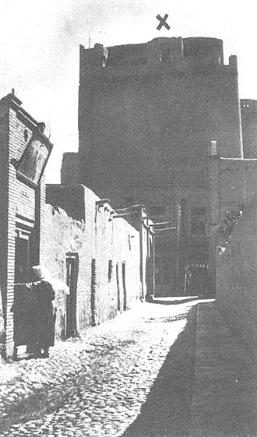
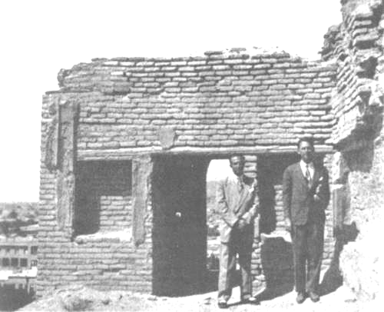
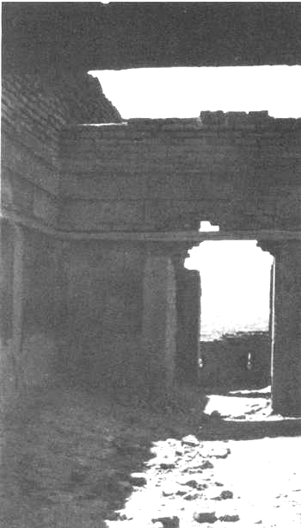
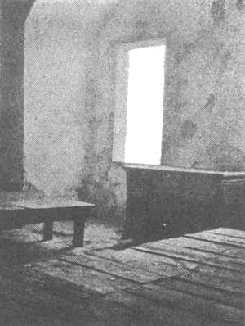
Citadel of Tabriz 1-5
Mah Ku 6-9
Chihriq 10
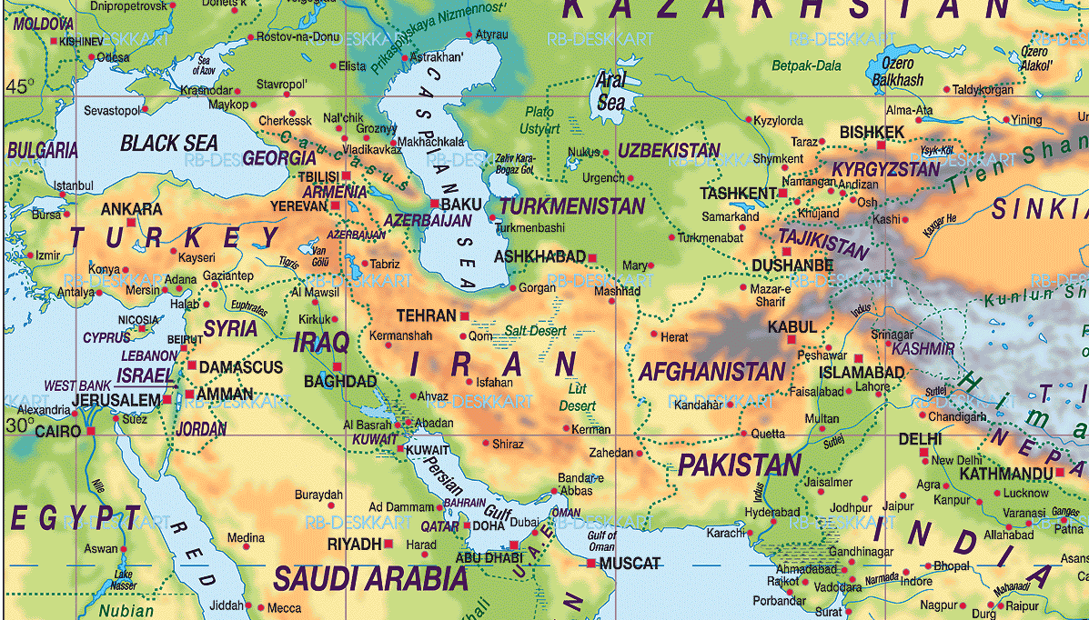
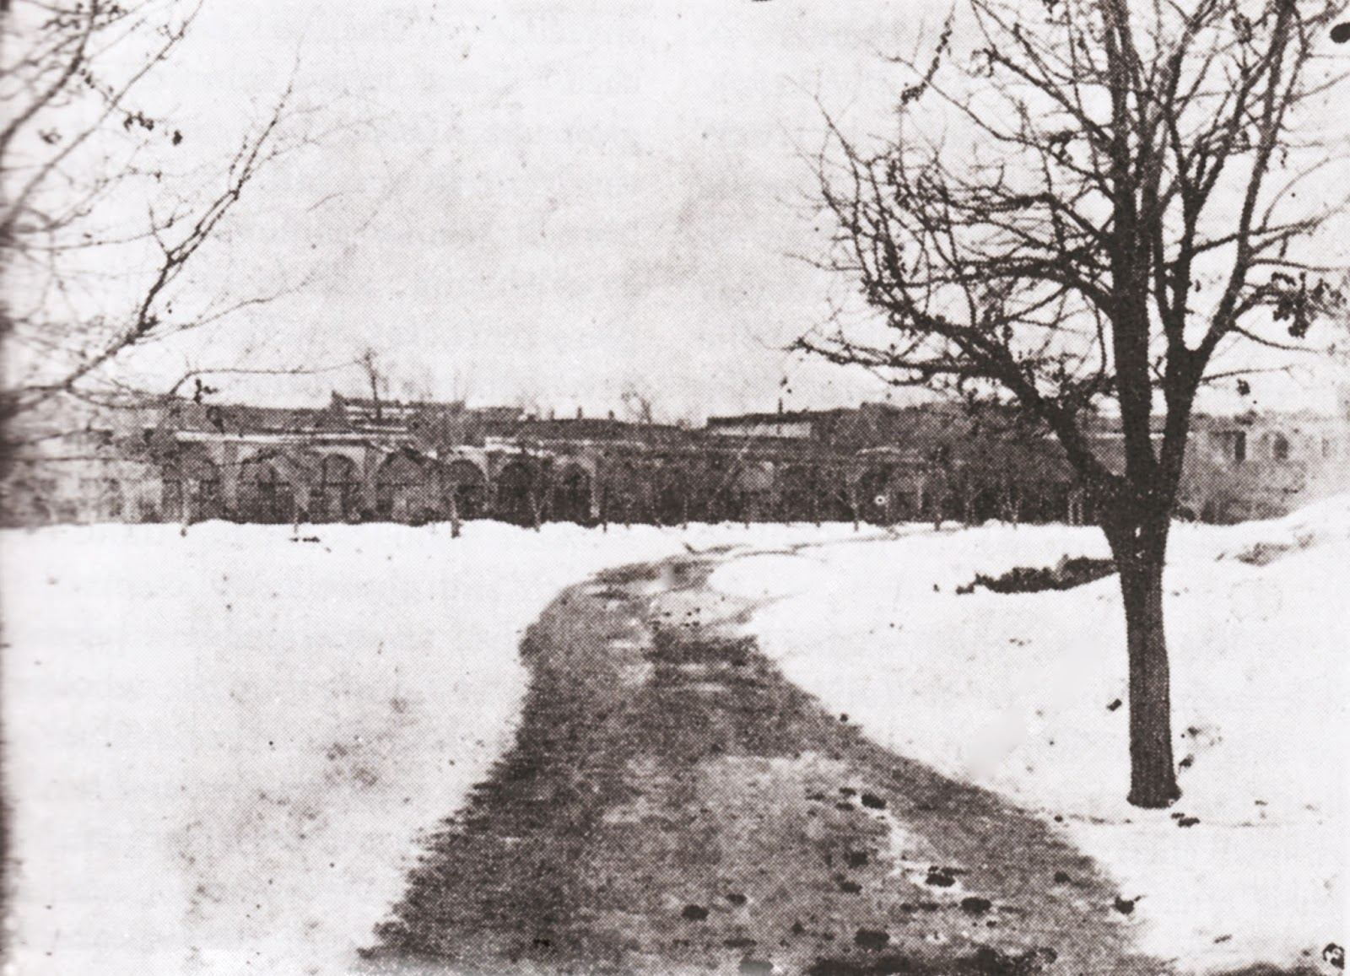
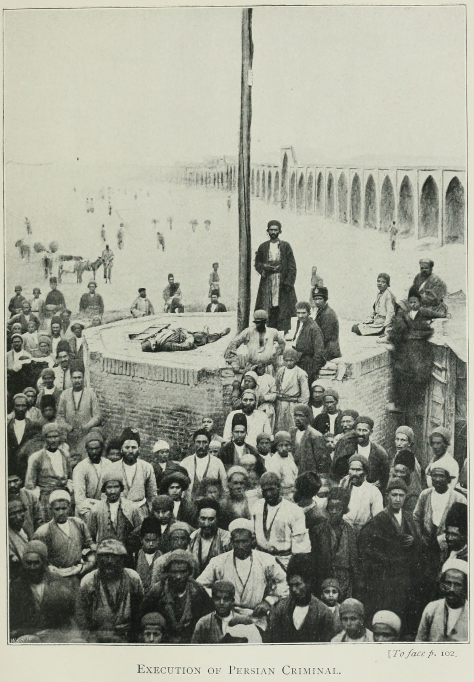
Images are referred left to right, top to bottom

Previous Page

Images 1-5 : Tabriz Citadel where the Báb was imprisoned 40 days en route to Mah Ku. In the second Image, X marks the Báb's Cell, Images 3-5 are the Báb's Cell.

Images 6-9 : Mah Ku, where the Báb was incarcerated.

Image 10 : Chihriq, where the Báb was imprisoned.

This Page

Top : The Barracks of Tabriz where the Báb was martyred (the spot is marked by a red X)

Middle : The Barracks, wide views.

Bottom : Map showing the place of birth (Shíráz), public declaration (Mecca) and martyrdom (Tabriz) of the Báb, as well as Máh Kú and Chihriq.
Tabriz
Shiraz
Mecca
x
Mah Ku
Chihriq

Some accounts have a small group of soldiers or omit observing anything unusual about the firing squad; most simply have it as a detachment of soldiers, all of which would be small (or relatively so) in number. The familiar portrayal of 750 soldiers forming a 125 metre-wide firing squad using the feeble, impossibly inaccurate guns of the time seem very unlikely to be true, certainly for the first volley, but there might have been a more dramatic show for the second volley.
Accounts generally have Anis either killed or near-fatally wounded. Abdu'l-Baha in a Q&A recorded in writing is asked explicitly about this and Abdu'l-Baha replies that Anis is martyred by the first volley.
Speeches recorded in histories should usually be understood as the gist of what was said rather than the exact words.
The story at this point of a whirlwind blotting out the sun from noon till night is missing in early accounts.

